
National University of Computer and Emerging Sciences Chiniot-Faisalabad Campus
BS (Artificial Intelligence)

Name | MUZAMMIL BIN SOHAIL
Roll. No. | 22F-3110
Section | BS(AI) SECTION A
Course | AI Lab
Lab | # 10
Department | AI & DS

a)
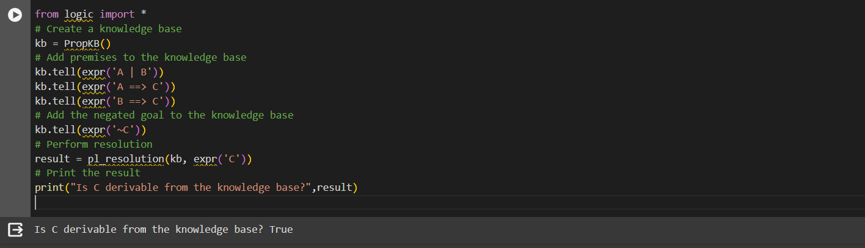
from logic import *
# Create a knowledge base
kb = PropKB()
# Add premises to the knowledge base
kb.tell(expr('A | B'))
kb.tell(expr('A ==> C'))
kb.tell(expr('B ==> C'))
# Add the negated goal to the knowledge base
kb.tell(expr('~C'))
# Perform resolution
result = pl_resolution(kb, expr('C'))
# Print the result
print("Is C derivable from the knowledge base?",result)

b)
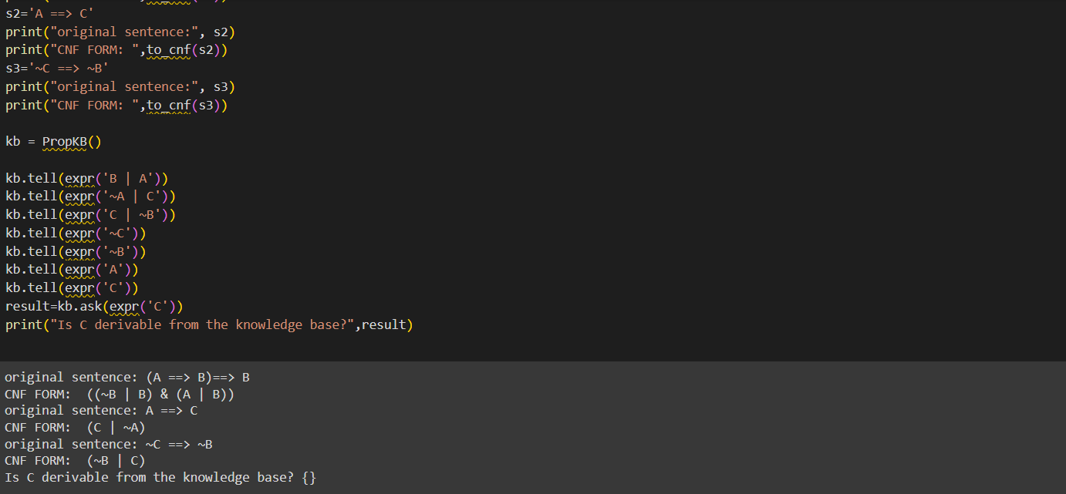
from logic import *

s1='(A ==> B)==> B'
print("original sentence:", s1)
print("CNF FORM: ",to_cnf(s1))
s2='A ==> C'
print("original sentence:", s2)
print("CNF FORM: ",to_cnf(s2))
s3='~C ==> ~B'
print("original sentence:", s3)
print("CNF FORM: ",to_cnf(s3))

kb = PropKB()

kb.tell(expr('B | A'))
kb.tell(expr('~A | C'))
kb.tell(expr('C | ~B'))
kb.tell(expr('~C'))
kb.tell(expr('~B'))
kb.tell(expr('A'))
kb.tell(expr('C'))
result=kb.ask(expr('C'))
print("Is C derivable from the knowledge base?",result)

c)
from utils import expr, FolkB, to_enf, fol_f_ask, pl_resolution

#these are the predicates of the given problem
American = expr ("American" )
Hostile = expr ("Hostile")
Sell = expr ("Sell")
Missiles = expr ("Missiles")
ColonelWest = expr ("ColonelWest")
Nono = expr ("Nono" )

kb = FolKB()
kb. tell(expr ("forall x: (American(x) & ColonelWest(x)) => Sell(x, Missiles(Nono))"))

goal = expr ("exists x: (American(x) & Sell(x, Missiles(Nono)))")

# now converting the fol to propositional logic for applying resoloution on it
kb_prop = to_cnf(fol_fc_ask(kb, expr("")))

#CONVERTING TO CNF
goal_prop = to_cnf (goal)
proof = pl_resolution (kb_prop, goal_prop)

if proof:
print("Colonel West is a criminal")
print (proof)
else:
print("Colonel West is not a criminal")

